Your Details
References (not family members please)
Referee 1
Name:

Daytime tel. number or email address:

Relationship to you:

Referee 2
Name:

Daytime tel. number or email address:

Relationship to you:
Thank you for your offer to help with the Yarmouth and Magdalen foodbank warehouse. In order for us to process your application please would you answer the following questions:
Yarmouth & Magdalen Foodbank
Warehouse Team Volunteer Application
Title:
Full Name:

Address:

Postcode:
Tel. (mobile preferably):
Email:
Date of Birth:
Contact in case of emergency (if different)
Name:
Tel No:
Relationship:
Next of Kin
Name:
Tel No:
Relationship:
I would be interested in helping regularly in the following area(s) please tick:
Areas of interest:
Sorting/Packing of incoming food | Yes/No
Driver - Delivery/collections | Yes/No
If interested in driving:
Do you have your own vehicle? | Yes/No
Would you be prepared to drive our van? | Yes/No
Do you have a clean driving license? | Yes/No

Do you have any health issues, care or support needs or disabilities that we should be aware of? (please circle) Yes / No
If yes, please give details:
Hours of interest: (please indicate the number of hours offered)
 | Mornings | Afternoons | Evenings
Mondays
Tuesdays
Wednesdays
Thursdays
Fridays
Saturdays
Occasional events such as harvest: |  | yes/no

Please tell us of any previous work, relevant training or volunteering experience or qualifications:
Safeguarding
The following questions are in line with our commitment to safer recruitment and ensuring we have sufficient support in place for volunteers.

Do you have any criminal unspent charges or convictions (under the Rehabilitation of Offenders Act 1974)? (NB: this does not necessarily prevent you from volunteering) Yes / No
If yes, please give details:

Has your name been placed on a list of people barred from working with children or vulnerable adults? (please circle) Yes/No

Are you currently under investigation by the police? (please circle) Yes / No

Have you signed a Church of England Confidential Voluntary Declaration? Yes/No
If yes, please provide a copy.

Have you received any safeguarding training? (please circle) Yes/No
If yes, please give details of training received in the last 3 years (date and type).

Please give us any other information you think may be useful to us:

Data protection
I confirm that the above information is complete and correct. I consent to the processing of this data in the consideration of my application and during the course of my volunteering, where applicable.
Signature: Date:
Signature of parent/guardian if applicant is under 18: Date:

Please return completed form to:
Warehouse Co-ordinator
Yarmouth & Magdalen Foodbank
Great Yarmouth Pathway
The Minster Mission
Admiralty Road
Great Yarmouth
NR 30 3DG

Email: iainjohnstone@yarmouthmagdalen.foodbank.org.uk

Any questions, call Iain Johnstone on tel.

Privacy Notice
Yarmouth & Magdalen Foodbank is operating under the umbrella of Great Yarmouth Pathway, in partnership with St Mary Magdalene Church. We are committed to protecting data privacy and will process your personal data in accordance with data protection legislation. Your data will only be used for purposes relating directly to your volunteering activity. It may only be shared with food bank personnel responsible for your volunteering, the Trussell Trust and specific systems provided by third-parties that directly support the running of the food bank.
Thank you for wanting
to help in our foodbank.
We will be in touch soon!

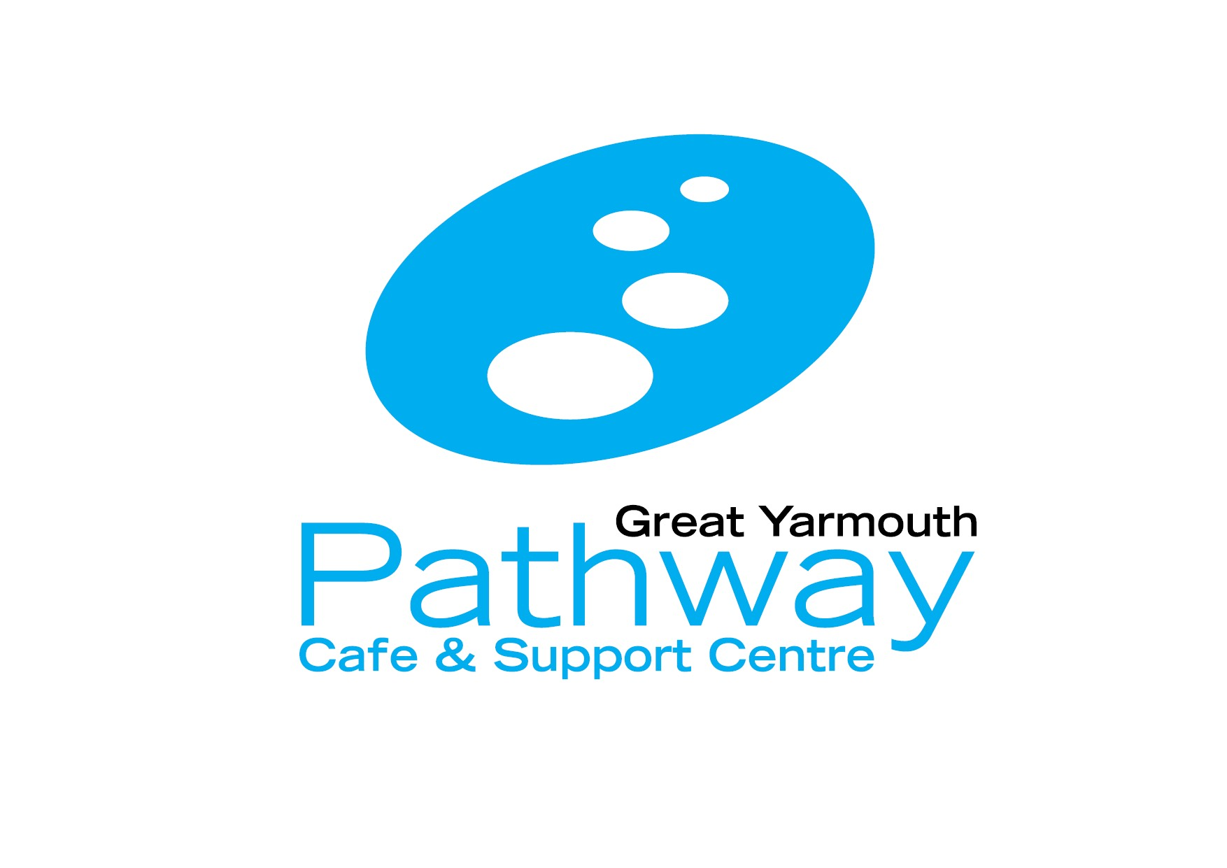
This application form will be kept either in a private, locked room or in a locked filing cabinet. Details from it will be entered into a secure online spreadsheet that is password protected on a password protected computer.

